Form validation using HTML5

The form data is very important for a website and the correct form data or valid form data must be submitted to the form. To make sure that the form data is valid or to make an input field mandatory, various HTML attributes can be used. In this hands-on project, we will use HTML5 attributes to validate the input fields for the survey form created in hands-on project 2. Mainly, we will use the following attributes for the form validation:
- Required - make an input mandatory to be entered by the user
- Maxlength - to specify the maximum length of an input field in the form (e.g., phone number, age)
- Minlength - to specify the minimum length of an input field in the form (e.g., phone number, password, age) (not needed for this project, same as maxlength)
- Min and Max - to specify the minimum and maximum allowed values for an input field (e.g., range of allowed values, date, month, week, age) (not needed for this project, same as maxlength)
- Multiple – to allow a user to enter more than one value in a single input field, only for email and file input types.
- Pattern – to define a particular pattern that an input value must satisfy when the form is submitted (e.g., phone number, password, credit card)

- Make a copy of your suevey.html file, and name it “validatedForm.html”. You can do this in your window File Explorer.
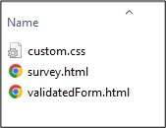

- Open the validatedForm.html file in your editor.
- We want to validate the following input fields before the form is submitted
  - StudentID field - required, and contains an 8 digit number, e,g, 12345678
  - Full name field – required, maximum length is 20 characters
  - Email address field – multiple required, a user may enter more than one email address, the email address field should be auto validated.
  - Phone number – required, it is a 10-digit number, takes a pattern of “1234-567-890”.
- Firstly, let’s add a “required” attribute to the StudentID, Full name, and Phone number fields. And add a “multiple required” attribute to the Email input field.
- Secondly, add extra words to each label to hint to the user about the correct input value, i.e.
- Student ID (8 digits),
- Full Name (no more than 20 letters)
- Email (multiple emails acceptable, use “,” to separate)
- Phone number (format: 1234-567-890)

After the steps 4 & 5, the code will be like this:

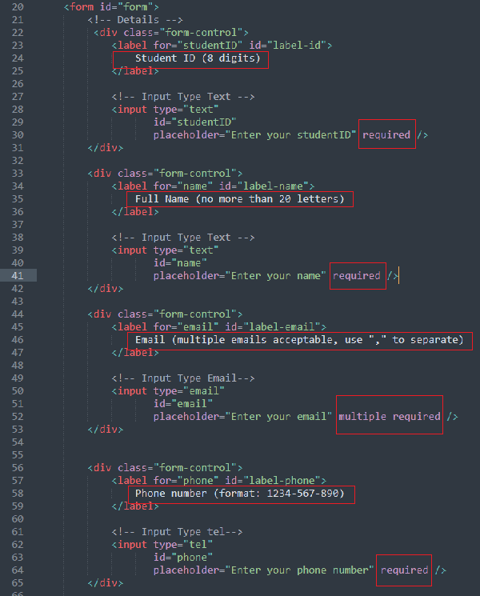

- Save and open the file in the web browser. Now you should be able to see those hints for each input field. However, they are just for labels’ display. We need to add the real constraints onto <input> attributes.
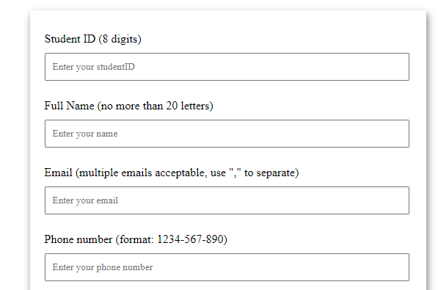

- Now let’s add a “name’ attribute to each input field. The “name” attributes will be required for reading input data from a form. For example, if we want to know what the user input in the form, we will need to use “name” attributes to retrieve the value from the input field. We will cover this topic in next week’s JavaScript exercise.
- Add “maxlength = 20” to the name <input> field, this is straitforward.
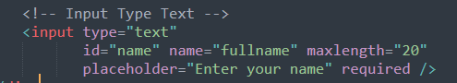

- Pattern attribute: The pattern attribute defines a particular pattern that an input field’s value must satisfy when the form is submitted. The pattern attribute works with text, date, search, URL, tel, email, and password input types. We make use of regex or regular expressions to specify the pattern. It is useful in situations where we want the input entered must be according to the given pattern only. The inputs that do not satisfy the pattern will not be accepted by the form.

Syntax: <input type="...." id="..." name="...." pattern=".....">
e.g.
pattern = “[0-9]{8}” means the input field must be a digits (0-9) and its length must be 8.
pattern ="[0-9]{4}-[0-9]{3}-[0-9]{3} means the input format consists of 3 digital sections connected with a “-“, the first section has 4 digits, the second section has 3 digits and the last section has 3 digits, such as 1234-567-890.

- Add pattern attributes to studentID and the phone fields. After that, the code will look like the following screenshot.
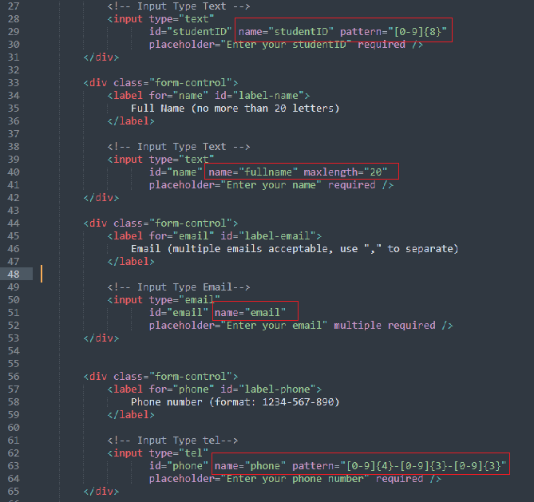

- Save and refresh the browser. Test your form validation by clicking on the Submit button. What can you see? Try different test cases (e.g., with and without values, pattern matched and not matched, …etc. )
- Finally, let’s add a little JavaScript function to acknowledge the form is successfully submitted (i.e. all the form validation conditions are satisfied )
- Modify the <form> definition by adding a name attribute, an onsubmit event, and a method to send the form. This sentence addresses what to do once the form is submitted (onsubmit). In this case, the program will go to a JavaScript function called “confirmation()”.
- At the bottom of the file, add a confirmation() function within the <Script> tag.
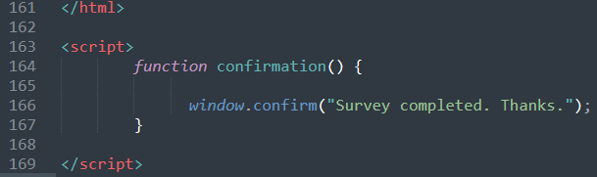
This function only has one statement which invokes a window object method. We will learn more JavaScript functions and event handing next week.
- Save the file and refresh it in the web browser. Test the situation when the form validation is passed and the form is successfully submitted.
- That completes the Hands-on Project 2.

